Train Departure Checklist

Description
The Train Departure Checklist is a comprehensive, multi-step process that must be completed by an Authorized User—either directly by the Train Crew via a field device or verbally with a Dispatcher—before a Train can depart. It functions as a final safeguard by validating critical items such as Job Briefings, Work Locations, Train Consist details, PTC initialization status and confirmation of the Active Dispatcher Bulletin. If the Train is not PTC enabled, the Train Crew will coordinate with the Dispatcher to complete the Departure Checklist. The Core System prevents signals from being cleared and EC1 Train Authorities from being issued until every Departure Checklist item has been confirmed.
The Departure Checklist items are configurable, with some items requiring acknowledgment (e.g., Job Briefing, PTC status) and other items are editable (e.g., Work Locations, Train Consist information, Dispatcher Bulletin number). For Work Locations, the system automatically redirects the Authorized User to the relevant feature, then returns them to the Departure Checklist upon completion. If the Authorized User enters Train Consist data that differs from the current Train Sheet, the Core System will prompt for confirmation before updating the Train Consist information. To ensure that a new Train Crew does not inadvertently assume control without completing the Departure Checklist, the Core System resets the checklist when a new Crew Set is activated, ensuring that each train’s departure meets all safety and operational protocols before proceeding.
The following diagrams show the activities that occur when an Authorized User fills out the Departure Checklist and the associated validations.
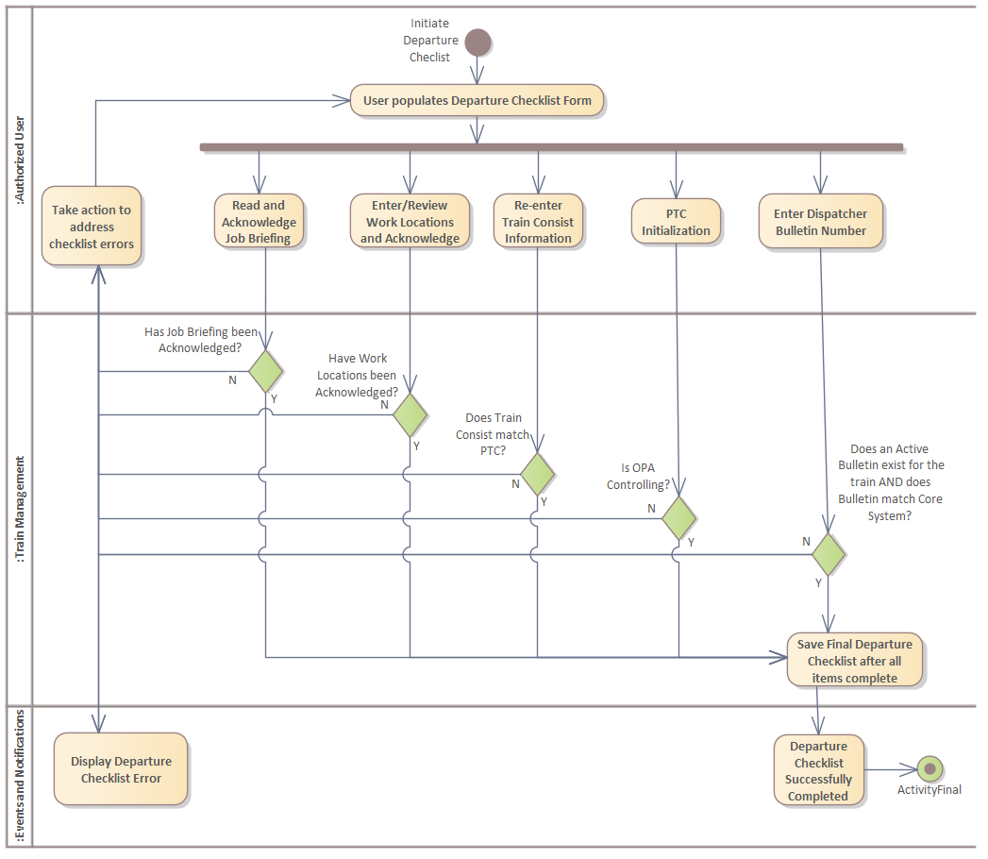
Figure 1. Train Departure Checklist Activity Diagram

Departure Checklist Initiation
When a Dispatcher Bulletin has been issued for a Train Sheet and PTC has been initialized for a Train with PTC enabled, the Train Management Subsystem shall enable the Departure Checklist feature and provide an option for an Authorized User to initiate the Departure Checklist associated with an existing Train Sheet.

Departure Checklist: Configurable Section Control
When an Authorized User configures the Departure Checklist, the Train Management Subsystem shall use five Boolean configuration parameters to control the visibility of each of the following checklist sections:
- Job Briefing Section (CFG-TM.CHECKLIST.BRIEFING)
- Work Locations Section (CFG-TM.CHECKLIST.WORK.LOCATIONS)
- Train Consist Section (CFG-TM.CHECKLIST. TRAIN.CONSIST)
- PTC Initialization Confirmation Section (CFG-TM.CHECKLIST.PTC.INIT)
- Dispatcher Bulletin Number Section (CFG-TM.CHECKLIST.BULLETIN)

Display of Departure Checklist Based on Configuration
When an Authorized User initiates the Departure Checklist, the Train Management Subsystem shall display only the sections that the corresponding boolean configuration parameter is set to True, allowing the Authorized User to populate that section and hide the sections for which the corresponding Boolean configuration parameter is set to False, bypassing all validation checks associated with the hidden section. are hidden.

Departure Checklist: Dispatcher Override Feature
** Authorized User agnostic to Train Crew vs Dispatcher (User Permissions handling out of scope)
When a Dispatcher needs to complete the Departure Checklist on behalf of the Train Crew through verbal communication, the Train Management Subsystem shall provide an option for the Dispatcher to initiate an override mode for the Departure Checklist and allow a flag to be recorded with the Departure Checklist in the Core System.

Departure Checklist Form: New Active Crew Set Reset Trigger
After an Authorized User has initiated the Departure Checklist and a new Crew Set is Activated within the Train Crew Consist, the Train Management Subsystem shall reset the Departure Checklist completion status to “incomplete” and clear any previously checked items.

Departure Checklist Preservation Functionality
When an Authorized User navigates away from an active Departure Checklist form during data entry, the Train Management Subsystem shall preserve the current state of the Departure Checklist and restore it upon the user’s return, thereby displaying the checklist with all previously entered information intact.

Departure Checklist Save and Exit Options
When an Authorized User initiates the Departure Checklist, the Train Management Subsystem shall provide options for the Authorized User to save and exit the Departure Checklist.

Departure Checklist Completion

Job Briefing Review and Acknowledgement
When an Authorized User initiates the Departure Checklist with the Job Briefing section visible, the Train Management Subsystem shall provide an option for the Authorized User to review the Job Briefing and an option to acknowledge that they have read and understood the Job Briefing only after the Authorized User has accessed the Job Briefing.

Work Locations Option
When an Authorized User initiates the Departure Checklist with the Work Locations section visible, the Train Management Subsystem shall provide an option for the Authorized User to view Work Locations and to acknowledge that they have reviewed Work Locations only after the Authorized User has accessed the Work Locations.

Work Locations Review and Re-direct Option
When an Authorized User accesses the view Work Locations option in the Work Locations section, the Train Management Subsystem shall display a prompt showing all scheduled Work Locations associated with the Train and shall provide an option that redirects the Authorized User to the Intermediate Destinations feature within the Train Sheet where the Authorized User can review and update Work Locations as needed.

Work Locations Review and Acknowledgement Option
After an Authorized User has completed Work Locations reviews and updates, the Train Management Subsystem shall provide an option to re-direct the Authorized User to the Departure Checklist and shall provide an option for the Authorized User to acknowledge that all Work Locations have been entered and reviewed.

PTC Initialization
When an Authorized User initiates the Departure Checklist with the PTC Initialization Confirmation Section visible, the Train Management Subsystem shall verify that the OPA is in the controlling state and provide an option for the Authorized User to acknowledge that PTC has been initialized. and verify that the OPA is in the controlling state.
Note: Refer to PTC SSRS for initialization (Link to Polarion Use Case, provide link when we update Polarion)

PTC Initialization Failure
If the OPA status does not match the Departure Checklist, the Train Management Subsystem shall notify the Authorized User of the PTC error and generate an event (EV-TM.DEPARTURE.CHECKLIST.PTC.INIT.FAILURE).

Dispatcher Populates Departure Checklist Incident Report Number
When a Dispatcher needs to complete the Departure Checklist on behalf of the Train Crew through verbal communication due to PTC failure, the Dispatcher assumes the role of the Authorized User and the Train Management Subsystem shall provide an option for the Authorized User to enter an incident number to complete the Departure Checklist.

Train Consist Option
When an Authorized User initiates the Departure Checklist with the Train Consist Section visible, the Train Management Subsystem shall provide an option for the Authorized User to re-enter the following Train Consist information within the Departure Checklist:
- Number of empty cars
- Number of loaded cars
- Train Length
- Train Tonnage
- Axle count
- Number of operative brakes
- Totes

Train Consist Validation
After the Authorized User has entered the Train Consist information within the Departure Checklist, the Train Management Subsystem shall validate that the Train Consist information entered matches the Train Consist information that was entered into the Train Consist in the Train Sheet and shall provide an option for the Authorized User to acknowledge that Train Consist overview has been confirmed.

Train Consist Mismatch
After the Authorized User has entered the Train Consist information within the Departure Checklist and the Train Management Subsystem if there is a mismatch between the Departure Checklist and Train Sheet, the Train Management Subsystem shall highlight the data field that is mismatched and prompt the Authorized User with a dialog requesting verification before updating the Train Sheet with the changed Train Consist information and shall log this confirmation.

Dispatcher Bulletin Number Option
When an Authorized User initiates the Departure Checklist with the Dispatcher Bulletin section Number visible, the Train Management Subsystem shall provide an option for the Authorized User to enter a Dispatcher Bulletin Number.

Dispatcher Bulletin Number Validation
After the Authorized User has entered the Dispatcher Bulletin Number within the Departure Checklist, the Train Management Subsystem shall validate that the Bulletin Number matches the Active Dispatcher Bulletin Number within PTC.

Dispatcher Messages
After an Authorized User completes the confirm Train's Dispatcher Bulletin Number section of the Departure Checklist, the Train Management Subsystem shall verify that there are no unnotified Dispatcher Messages required by the Train and shall notify the Authorized User if any messages exist and generate an event (EV-TM.DEPARTURE.CHECKLIST.UNNOTIFIED.DISPATCHER.MESSAGES).

Bulletin Number Mismatch: Error Correction Option
After the Authorized User has entered the Dispatcher Bulletin Number within the Departure Checklist and the Train Management Subsystem if the Dispatcher Bulletin Number does not match the Active Dispatcher Bulletin recorded within the Train Sheet, the Train Management Subsystem shall prevent completion of the Departure Checklist and provide an option for the Authorized User to correct the error.

Bulletin Number Mismatch: Update Active Bulletin Number
If there is a Dispatcher Bulletin Number mismatch between the Departure Checklist and the Train Sheet and if the Train is PTC enabled, the Train Management Subsystem shall require the Train Crew to activate the correct Bulletin for the Train either electronically or verbally with the Dispatcher before allowing the Departure Checklist to be completed.

Departure Checklist Identifier and Date
When an Authorized User completes any section of the Departure Checklist, the Train Management Subsystem shall log and display the timestamp and Authorized User identifier within the corresponding completed section of the Departure Checklist.

Departure Checklist Proceed with Departure
After the Authorized User has completed the Departure Checklist and all items have been acknowledged and validated, the Train Management Subsystem shall provide an option for the Authorized User to proceed with Departure Checklist completion.

Departure Checklist Complete and Save
When an Authorized User selects to proceed with Departure Checklist completion, the Train Management Subsystem shall display a confirmation dialog requesting the Authorized User to confirm departure readiness, and upon confirmation, save the Departure Checklist as part of the Train Sheet and generate an event (EV-TM.DEPARTURE.CHECKLIST.SUCCESS). to indicate that the

New Configurable Parameters
Param ID | Name | Feature | Type | Format | Default Value | Scope
CFG-TM.CHECKLIST.BRIEFING | Departure Checklist - Job Briefing Section | Train Sheet | Boolean | TRUE, FALSE | TRUE | Train Management Subsystem
CFG-TM.CHECKLIST.WORK.LOCATIONS | Departure Checklist - Work Locations Section | Train Sheet | Boolean | TRUE, FALSE | TRUE | Train Management Subsystem
CFG-TM.CHECKLIST. TRAIN.CONSIST | Departure Checklist - Train Consist Section | Train Sheet | Boolean | TRUE, FALSE | TRUE | Train Management Subsystem
CFG-TM.CHECKLIST.PTC.INIT | Departure Checklist - PTC Initialization Confirmation Section | Train Sheet | Boolean | TRUE, FALSE | TRUE | Train Management Subsystem
CFG-TM.CHECKLIST.BULLETIN | Departure Checklist - Dispatcher Bulletin Number Section | Train Sheet | Boolean | TRUE, FALSE | TRUE | Train Management Subsystem

